**Assignment 2, Data Mining**

**Nurtas Serikkanov**

Put all deliverables into github repository in your profile. Share link to google form 24 hours before defense. Defend by explaining deliverables and answering questions.

Deliverables: .ipynb

Google form: <https://docs.google.com/forms/d/e/1FAIpQLSe0GyNdOYlvM1tX_I_CtlPod5jBf-ACLGdHYZq1gVZbUeBzIg/viewform?usp=sf_link>

### **Exercise 1: Feature Selection with SelectKBest**

**Objective**: Use SelectKBest from scikit-learn to select the top k features from a dataset.

1. Load the Iris dataset from scikit-learn.
2. Split the dataset into features and target variable.
3. Use SelectKBest with the chi2 score function to select the top 2 features.
4. Print the selected feature names.

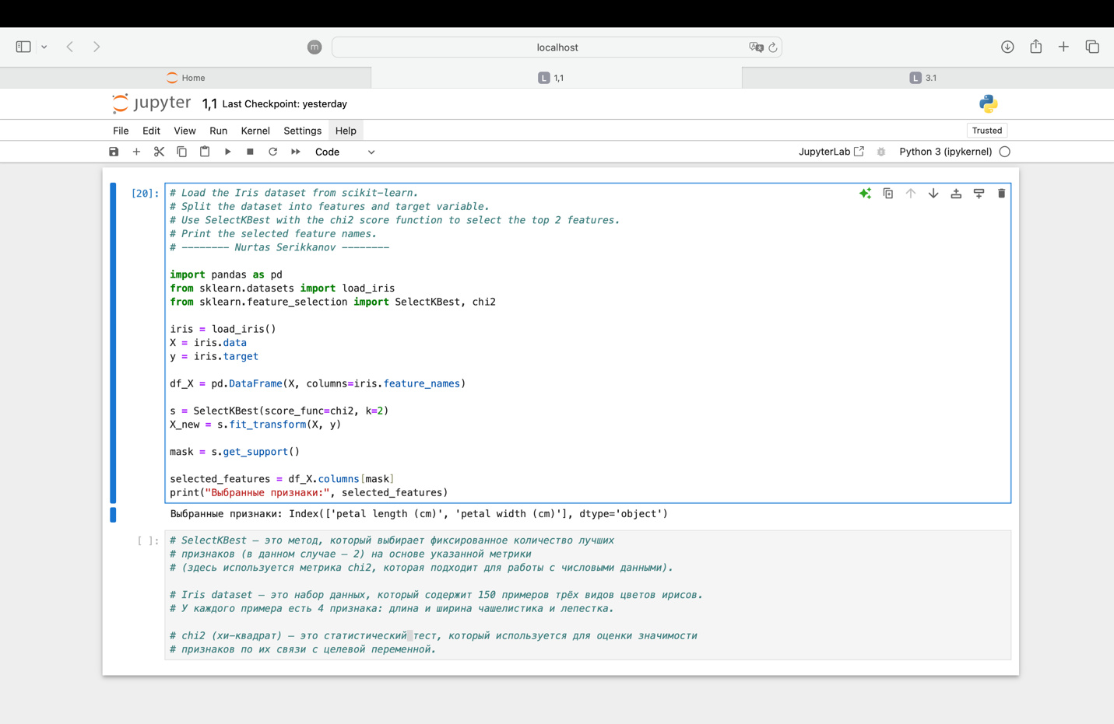

### **Exercise 2: Feature Importance with Random Forest**

**Objective**: Use a Random Forest classifier to determine feature importance.

1. Load the Wine dataset from scikit-learn.
2. Split the dataset into training and testing sets.
3. Train a Random Forest classifier on the training data.
4. Extract and visualize feature importances.

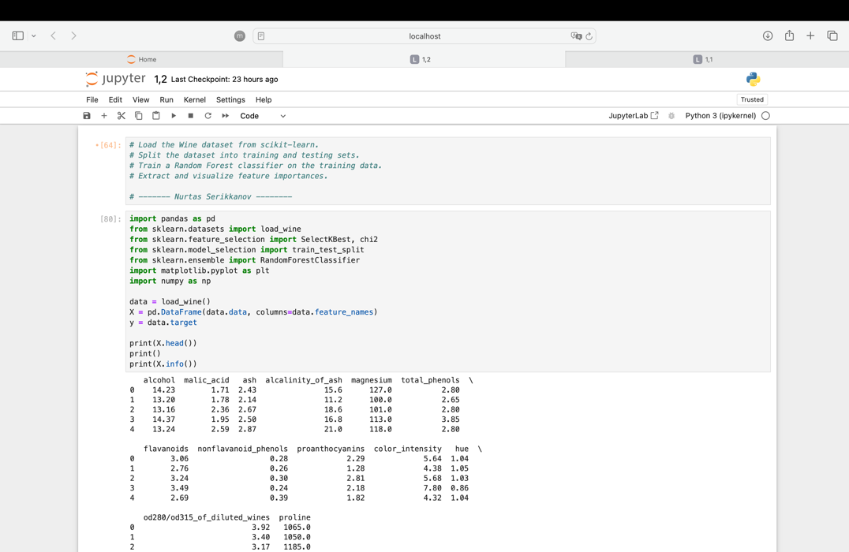

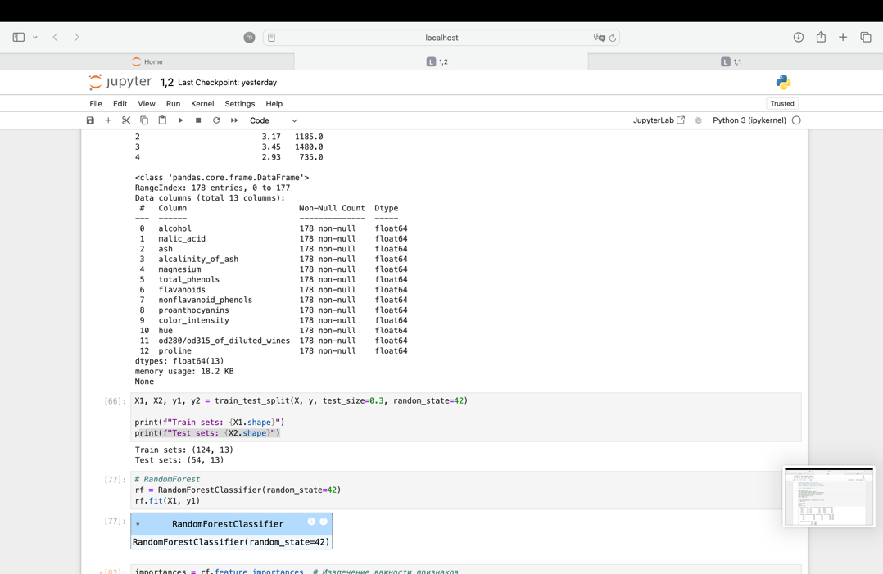

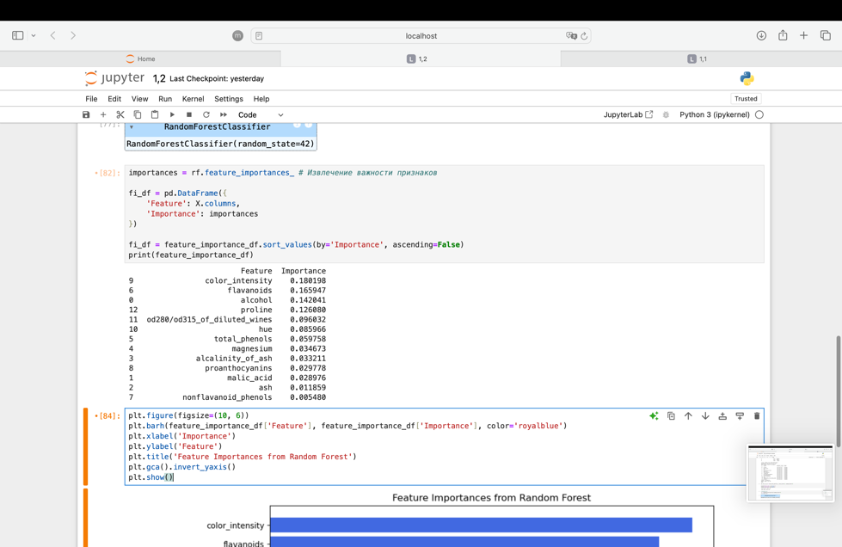

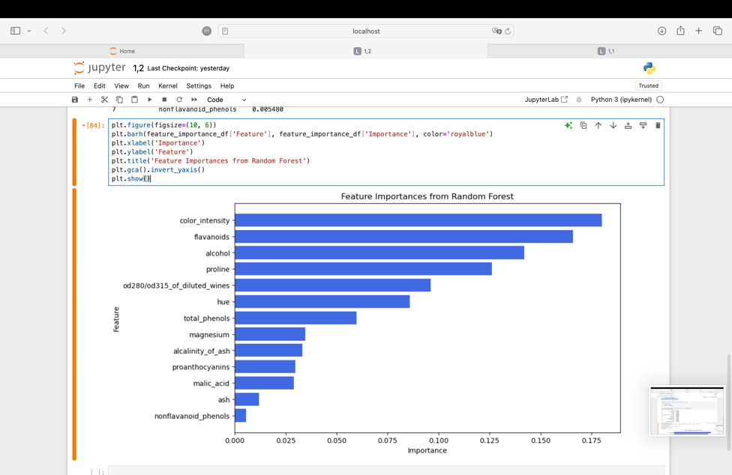

### **Exercise 3: Recursive Feature Elimination (RFE)**

**Objective**: Use Recursive Feature Elimination (RFE) to select features and evaluate model performance.

1. Load the Breast Cancer dataset from scikit-learn.
2. Split the dataset into training and testing sets.
3. Use RFE with a Support Vector Machine (SVM) classifier to select features.
4. Train an SVM model with the selected features and evaluate its performance.

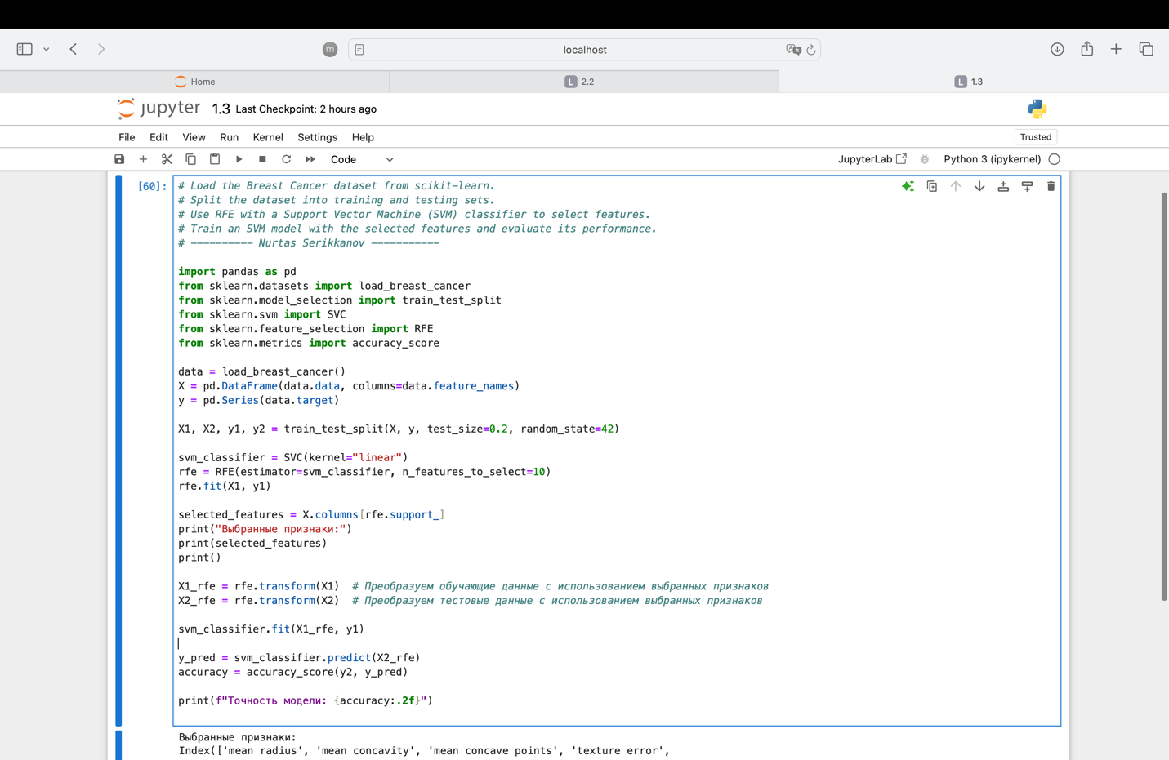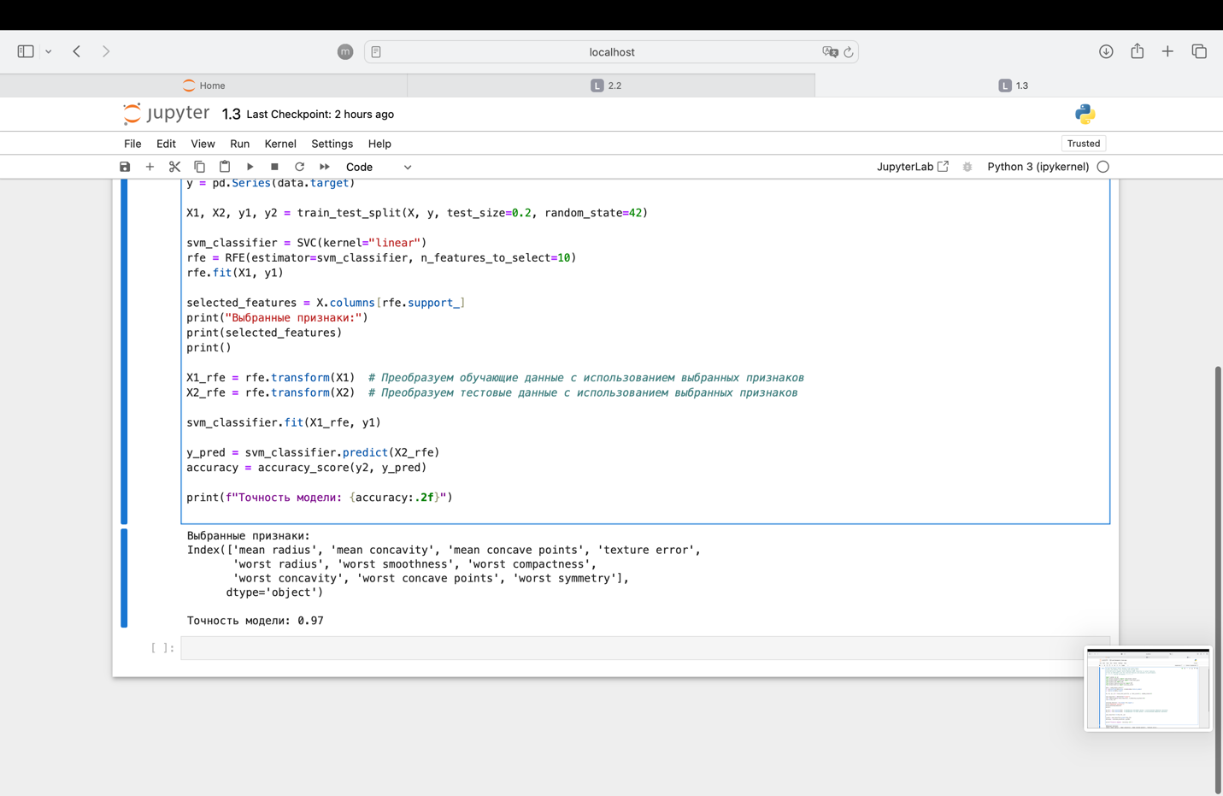

### **Exercise 4: L1 Regularization for Feature Selection**

**Objective**: Use L1 regularization (Lasso) for feature selection.

1. Load the Diabetes dataset from scikit-learn.
2. Split the dataset into training and testing sets.
3. Apply Lasso regression for feature selection.
4. Train a model using selected features and evaluate its performance.

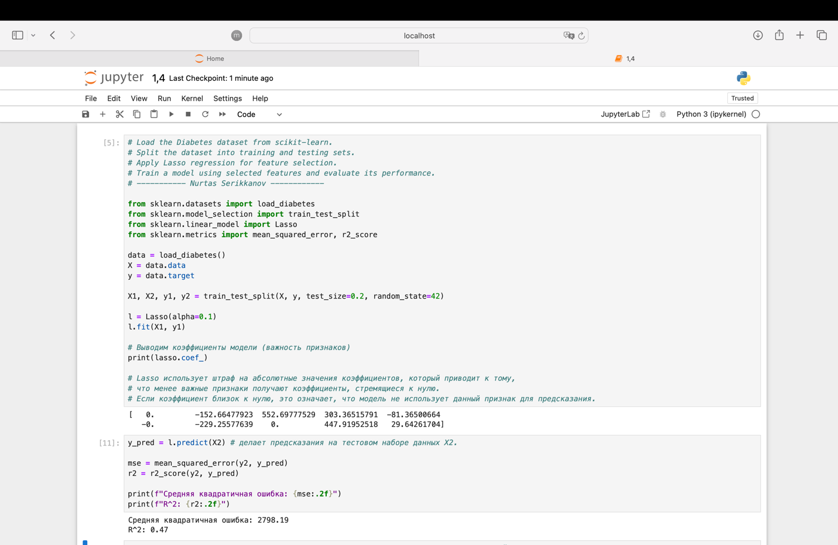

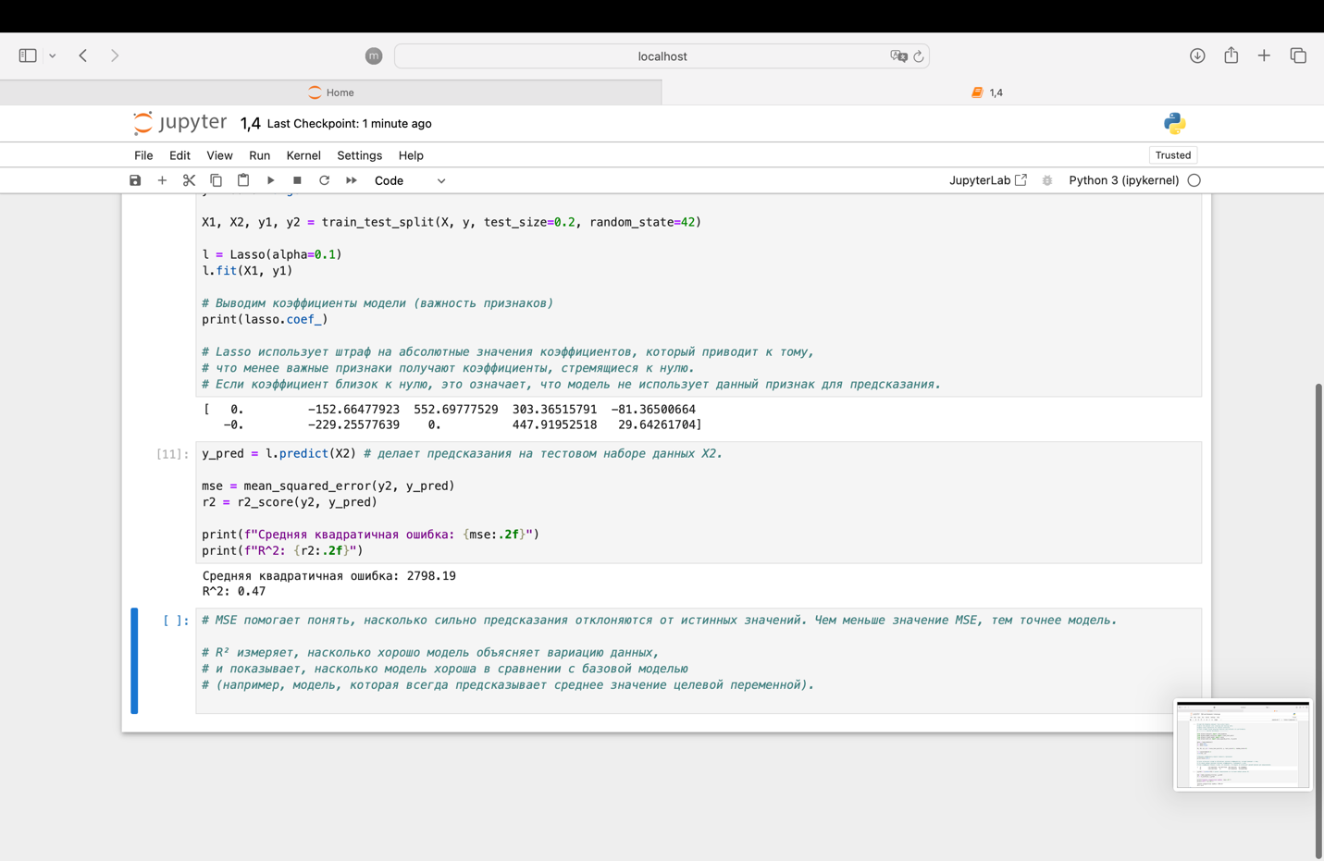

### **Classification Exercises**

#### **Exercise 1: Logistic Regression**

**Objective**: Build a logistic regression model to classify data.

1. Load the Iris dataset from scikit-learn.
2. Split the dataset into training and testing sets.
3. Train a logistic regression model on the training set.
4. Evaluate the model's performance on the test set using accuracy and a confusion matrix.

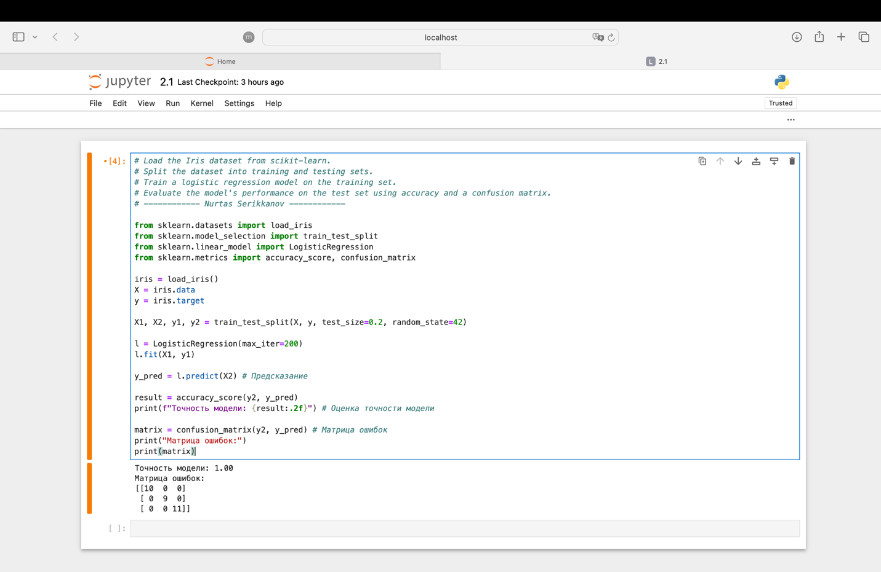

#### **Exercise 2: Support Vector Machine (SVM)**

**Objective**: Use an SVM classifier to classify data.

1. Load the Breast Cancer dataset from scikit-learn.
2. Split the dataset into training and testing sets.
3. Train an SVM model on the training data.
4. Evaluate the model's performance on the test data using accuracy and a confusion matrix.

#### **Exercise 3: Decision Tree Classifier**

**Objective**: Build a decision tree classifier and visualize it.

1. Load the Wine dataset from scikit-learn.
2. Split the dataset into training and testing sets.
3. Train a decision tree classifier on the training set.
4. Visualize the decision tree.

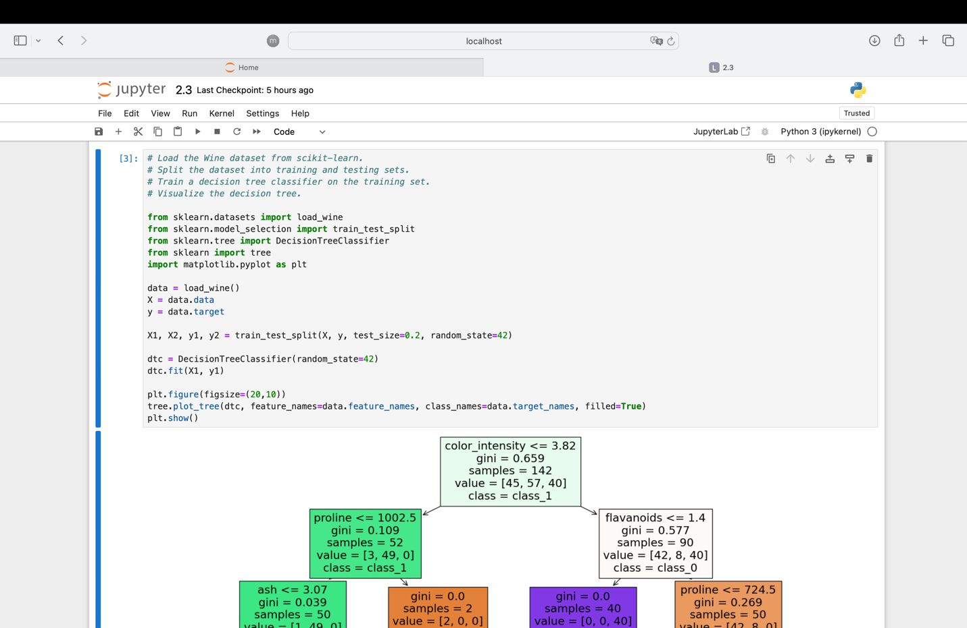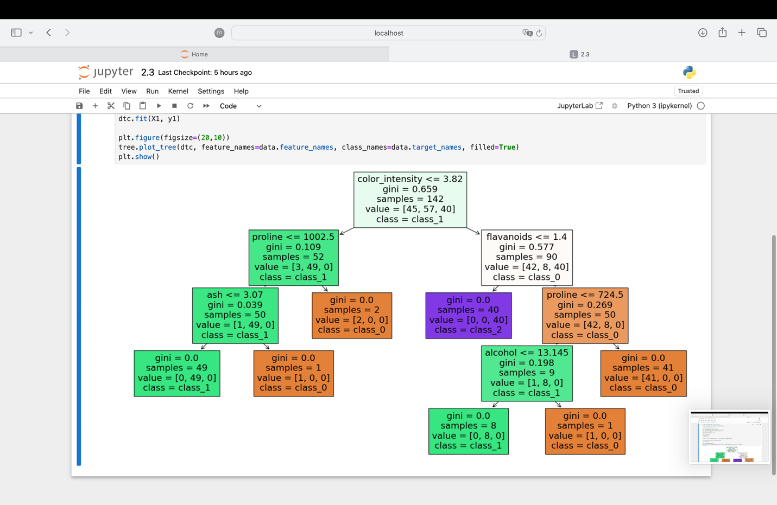

### **Regression Exercises**

#### **Exercise 1: Linear Regression**

**Objective**: Build a linear regression model to predict a continuous target variable.

1. Load the Boston Housing dataset from scikit-learn.
2. Split the dataset into training and testing sets.
3. Train a linear regression model on the training set.
4. Evaluate the model's performance using mean squared error (MSE) and R-squared score.

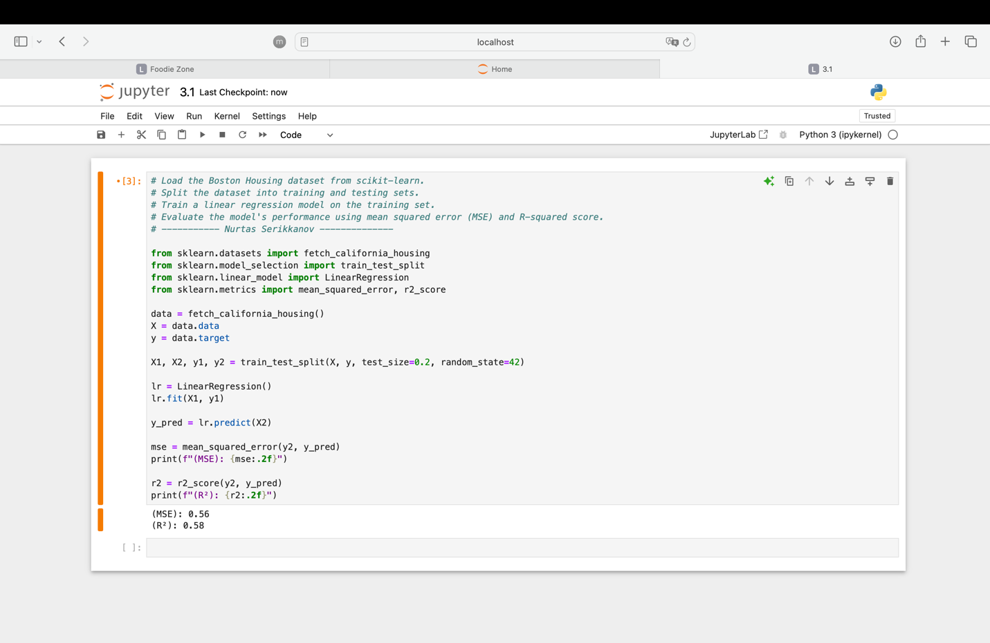

#### **Exercise 2: Ridge Regression**

**Objective**: Use Ridge regression to perform regularized linear regression.

1. Load the Diabetes dataset from scikit-learn.
2. Split the dataset into training and testing sets.
3. Train a Ridge regression model on the training set.
4. Evaluate the model's performance using mean squared error (MSE) and R-squared score.

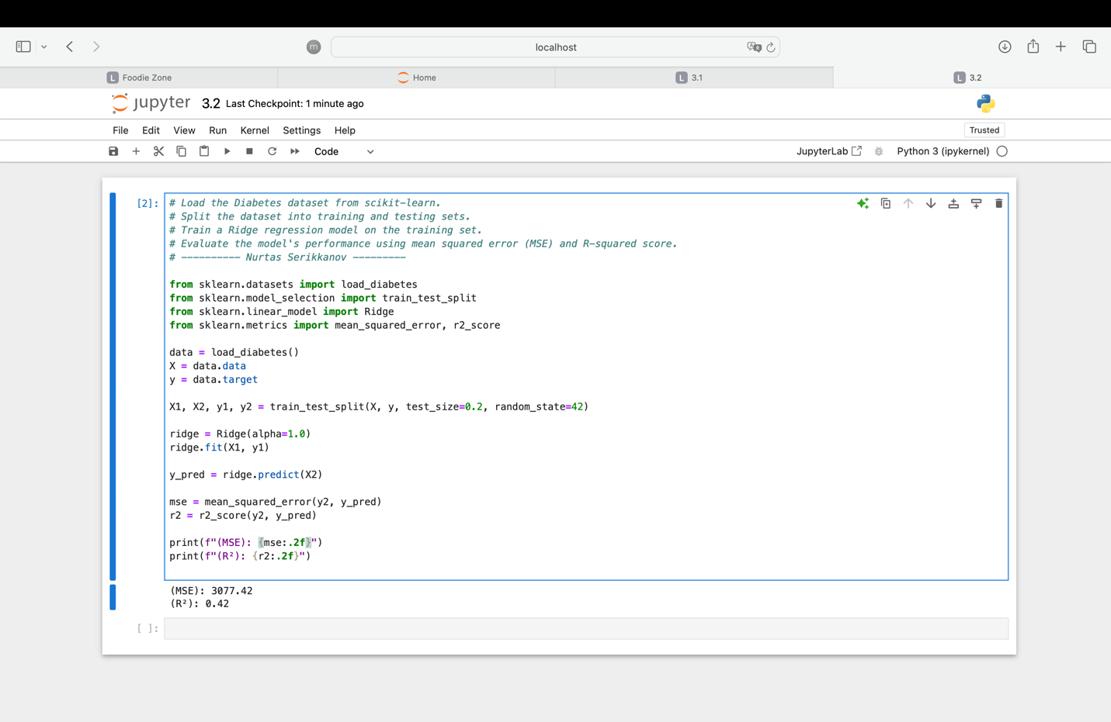

#### **Exercise 3: Decision Tree Regression**

**Objective**: Build a decision tree regression model and visualize it.

1. Load the Boston Housing dataset from scikit-learn.
2. Split the dataset into training and testing sets.
3. Train a decision tree regressor on the training set.
4. Evaluate the model's performance using mean squared error (MSE).
5. Visualize the decision tree.

